PRESS RELEASE: GLOUCESTER FOLK TRAIL 2023
Come and enjoy Gloucester Folk Trail this February. Gloucester’s folk-tastic event returns next month with new venues and more workshops.
For 2023 the festival sees the return of The Folk of Gloucester, plus new business Mister’s Café, The Pelican Inn, Dean’s Walk Inn and Warehouse 4 as hosts of folk acts and workshops. With over 40 acts, thirteen venues and ten Morris sides the city will be a vibrant hub for the weekend.
Michael Hall, Landlord of The Pelican Inn, says:
“The Gloucester Folk Trail has grown into one of the highlights of the year in Gloucester. It’s a privilege for The Pelican to be involved in this wonderful event which draws local businesses, musicians and music lovers together in a creative, collaborative, serendipitous way.”
Alex Cooke, Operations Manager at The Folk of Gloucester says:
‘’The Folk and its volunteers are looking forward to being a bigger part of the Folk Trail this year. We will have good food, a bar serving Gloucester Brewery ale and excellent music.’’
As well as the three days of music acts, the Saturday will see the gate streets a wash with morris sides. Between 11am and 3pm ten morris dance groups will be taking a spot on the street to entertain spectators and passers-by; and if you fancy learning a move or two, there is a Broom dance workshop, returning for a second year, and an Appalachian Tap dance workshop for you to start your folk dancing journey.
Another new workshop for this year is Songwriting with Gloucester Songwriters’ Circle
Jim Rowley, Member of the Gloucester Songwriters’ Circle, says:
“Gloucester Songwriters’ Circle are delighted to be hosting an introduction to songwriting workshop at the Folk of Gloucester at 1pm on Saturday February 18th. The session will look at: lyric writing; melody; chord progressions, and more – all the tools to get you started!’
This is a great event to enjoy folk, discover Gloucester and support local businesses, brought to you thanks to the support and funding from Gloucester BID (Business Improvement District), The Green Stage, Match Factory Studios and all of the venues:

Angie’s
The Common Room
Dean’s Walk Inn
The Folk of Gloucester
Gloucester Guildhall
Mister’s Café
The New Inn
The Pelican Inn
Pilgrims Yard
Soundhouse
The Tall Ship
The Turk’s Head
Warehouse 4

Toby Wooldridge, Gloucester BID, says:
‘It is an event that has grown over the last six years, and we must thank all those who have made it happen again this year; the programmers’ dedication and the venues support does not go unnoticed. This event has something for everyone, from fledgling folkies to hard-core followers, with local acts and slightly further afield performers coming to the city’.
The Gloucester Folk Trail is on from 17-19 February, please head to www.gloucesterfolktrail.com for the full line up and links to the workshops.
For more information, please contact gloucesterfolktrail@gmail.com Photo credit: Chris Pearson, CPE Photography.
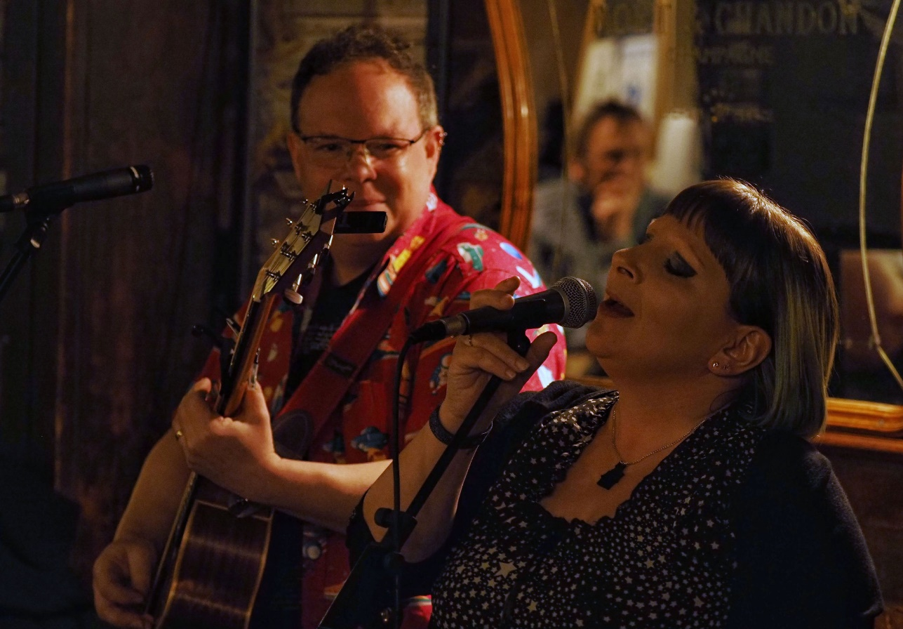
The Vogwells (2022)
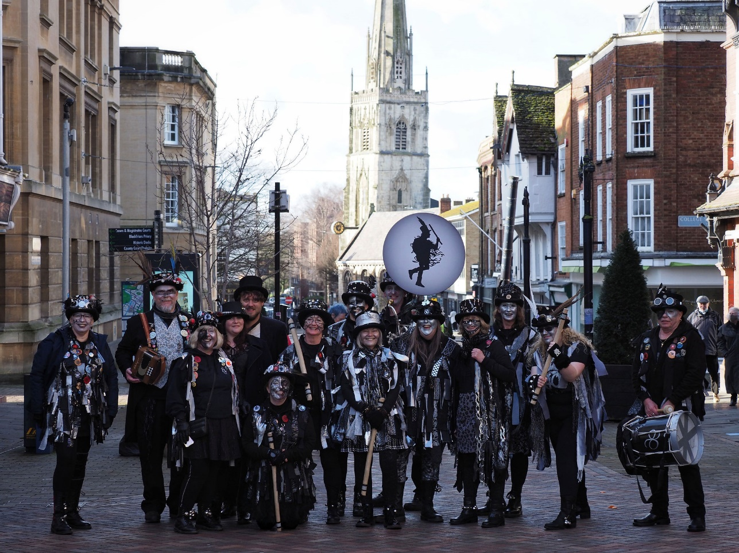
Aelfgythe Border Morris (2022)

